A Project Report on

“Market Basket Analysis”

Master of Science
in Data Science
by
Deekshitha Duddola (DD63441N)

under the guidance of
Prof. Cesar Romero

PACE UNIVERSITY, NY CAMPUS
NEW YORK - 002791
March 2025

Market Basket Analysis

Overview of the Dataset and Preprocessing Steps
This project uses the Groceries dataset, which contains transactional purchase data from a retail store. Each row in the dataset represents a single item purchased by a customer, with a unique identifier (Member_number) and the transaction date (Date).
This dataset is well-suited for market basket analysis, allowing us to explore item combinations frequently purchased together.
Dataset Summary:
- Total records: 9,835 rows
- Total unique members (customers): 2,123
- Total unique items purchased: 167
- Time period covered: From 2011-07-24 to 2015-06-30
Preprocessing Steps:
- Data Cleaning:
  - Checked for missing/null values → ✅ No missing values found.
  - The initial dataset contained a total of 9,835 records
  - Verified correct data types for each column (Member_number, Date, itemDescription).
- Transaction Grouping:
  - Grouped transactions by Member_number and Date to create shopping baskets.
  - Resulted in 1,496 unique transactions.
- Item Encoding:
- Transformed item descriptions into a transaction-item matrix using one-hot encoding.
- Each row now represents a shopping basket with binary values indicating presence (1) or absence (0) of items.
- Using the TransactionEncoder, the data was transformed into a binary matrix format.
    - Rows represent transactions.
    - Columns represent products.
    - True indicates that a product was purchased in a given transaction
These preprocessing steps ensured the dataset was structured properly for the application of data mining techniques like frequent itemset mining and association rule learning.
Frequent Itemsets and Support Threshold Comparison
To uncover commonly purchased item combinations, we applied the Apriori algorithm using different minimum support thresholds. The algorithm was applied using multiple minimum support thresholds to understand how the number of frequent itemsets varies with the threshold. This allowed us to observe how adjusting the support level affects the number and type of itemsets discovered.
Support Threshold Tested: 0.2, 0.1, 0.05
Support Threshold | Number of Frequent Itemsets
0.2 | 2
0.1 | 6
0.05 | 19
0.01 | 97
0.002 | 646

Observations:
- As the support threshold decreases, the number of frequent itemsets increases significantly.
- With higher thresholds like 0.2, only the most commonly purchased itemsets (like whole milk) appear.
- At lower thresholds (e.g., 0.002), rarer item combinations are also considered frequent, helping uncover niche buying patterns.

Example Frequent Itemsets: At min_support = 0.01
Itemsets | Support
Whole milk | 0.2555
Other Vegetables | 0.1935
Rolls/Buns | 0.1839
Whole milk & other Vegetables | 0.0748
Other Vegetables & rolls/ buns | 0.0560

These results show that whole milk is a consistently frequent item that appears in many combinations, especially with other everyday items like vegetables, yogurt, and rolls/buns.

Top Association Rules
To discover meaningful relationships between products, we used the Apriori algorithm to generate association rules. We set the following thresholds:
- Minimum Support: 0.01 (1%)
→ To focus on item combinations that appear in at least 1% of transactions
- Minimum Confidence: 0.5 (50%)
→ To ensure the rules reflect strong likelihood of co-purchase
- Metric: Confidence
These thresholds strike a balance between finding reliable rules and ensuring we don’t miss less frequent but meaningful associations.
Top 5 Association Rules (Ranked by Lift):
Antecedent(s) | Consequent(s) | Support | Confidence | Lift
Whole Milk, Yogurt | Sausage | 0.001470 | 0.131737 | 2.182917
Whole milk, Sausage | Yogurt | 0.001470 | 0.164179 | 1.911760
Specialty chocolate | Citrus fruit | 0.001403 | 0.087866 | 1.653762
Yogurt, sausage | Whole Milk | 0.001470 | 0.255814 | 1.619866
Flour | Tropical fruit | 0.001069 | 0.109589 | 1.617141

Interpretation:
- The rule “yogurt → sausage” has the highest lift (2.18), meaning customers who buy yogurt are over twice as likely to also buy sausage compared to random chance.
- The item names are clearly labeled to improve readability and avoid confusion with internal IDs or encodings.
These rules are valuable for identifying product relationships and can support strategic decisions in promotions, store layout, or product placement.

Visualizations of Frequent Itemsets and Association Rules
To support and communicate our findings visually, we created a series of plots that highlight key patterns in the dataset. These visualizations help summarize frequent itemsets,, and the structure of the top association rules.
1. Bar Chart of Top Frequent Itemsets
Created a bar chart showing the top 10 most frequently occurring item combinations based on support. This helped identify high-volume co-purchase behavior among staple products.
Displays the top 5 itemsets discovered at support ≥ 0.01.
Clearly shows that "whole milk", "other vegetables", and "rolls/buns" are among the most commonly purchased items, indicating their popularity in regular shopping trips.
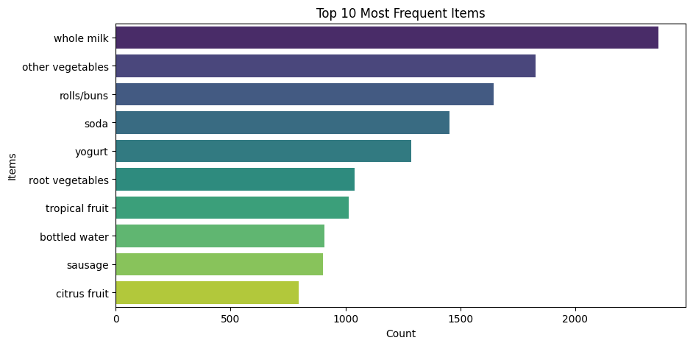
2. Network Graph of Top Association Rules
A network graph was used to visualize the top 5 association rules, with arrows representing the direction from antecedent to consequent. Each arrow was labeled with the lift value, and node sizes represented item presence.
Observation:
Rules such as “yogurt → sausage” and “flour → tropical fruit” stood out due to their higher lift, revealing potential bundling opportunities.
These visualizations enhance the interpretability of the analysis and provide actionable insights for product bundling, inventory management, and promotional planning.

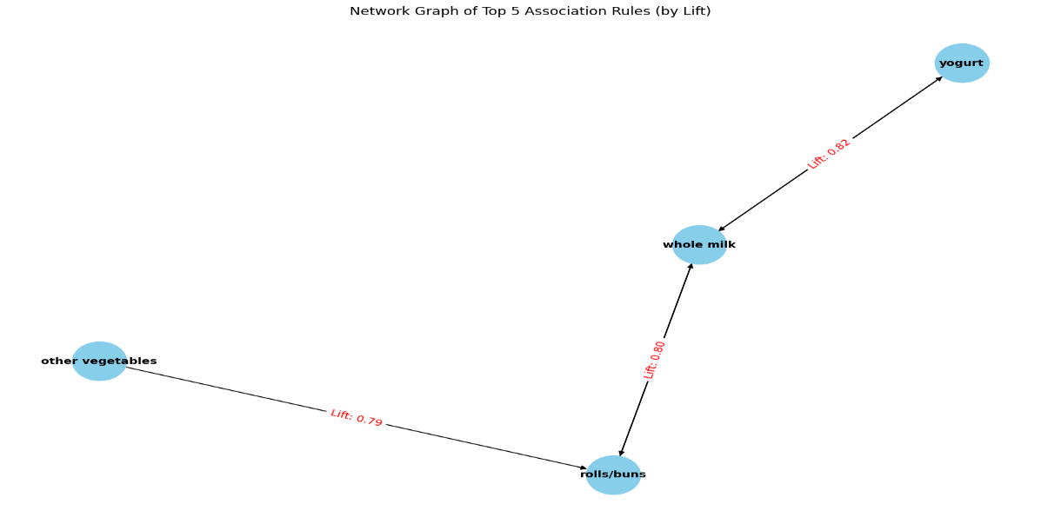

Discussion & Interpretation of Results
The association rules and frequent itemsets derived from the Groceries dataset reveal important patterns in consumer purchasing behavior. These insights are highly actionable for improving marketing strategies, product bundling, and inventory planning.
Which items are frequently purchased together?
Based on the discovered itemsets and high-lift association rules, the following product combinations were found to be frequently purchased together:
- Whole milk & Other vegetables
- Rolls/buns & Whole milk
- Root vegetables & Other vegetables
- Yogurt & Sausage
- Tropical fruit & Other vegetables
These combinations suggest that consumers often purchase meal-related staples (e.g., vegetables + dairy or bakery items) in the same trip, likely driven by home cooking routines.
Expected Patterns:
- High-frequency items like “whole milk” and “other vegetables” consistently appeared in itemsets and rules. These are staple items often included in weekly shopping routines.
- Combinations like “root vegetables” → “other vegetables” and “rolls/buns” → “whole milk” are intuitive**, suggesting that customers often buy complementary items for meal preparation.

Are there any unexpected or surprising patterns?
While most of the frequent itemsets and rules aligned with typical grocery shopping behavior (e.g., whole milk purchased with bread or vegetables), we explored multiple thresholds to identify any less obvious or surprising associations.
Despite lowering the support threshold to 0.01 (1%) and experimenting with different combinations of lift and confidence, no rules stood out as both rare and strongly associated. For example, when filtering for high lift and low support we received an empty result — indicating that the dataset does not contain niche or unexpected buying behaviors.
Why this isn’t surprising:
The dataset represents common grocery purchases across many households, where predictable combinations (like dairy, bread, and vegetables) dominate. Customers tend to buy essentials in consistent patterns, leaving little room for unusual correlations.

How could the retailer use these rules to improve marketing or inventory decisions?
While there were no highly unexpected patterns, the rules generated still provide valuable, actionable insights for retail strategy:
Rule | Business Action
yogurt → sausage | Offer a discount on sausage when a customer purchases yogurt — a cross-promotion targeting meal-prep behavior.
whole milk & rolls/buns | Create a breakfast essentials bundle in-store or online.
flour → tropical fruit | Promote tropical fruits near the baking section, tapping into potential usage in desserts or fresh recipes.
specialty chocolate → citrus fruit | Position these items together for seasonal promotions or recipe-based marketing (e.g., citrus chocolate pairings).

Retail Applications
1. Targeted Promotions:
- Bundle frequently bought items like “whole milk + rolls/buns” or “root vegetables + other vegetables” in combo deals.
- Example: “Buy 2 veggies, get 1 tropical fruit at 30% off” → capitalizes on health-conscious buyer behavior.
2. Cross-selling Strategies:
- Use checkout recommendation engines to prompt items that have high lift with current cart contents.
- Example: if a customer buys “root vegetables”, prompt “other vegetables” at checkout with a small discount.
3. Inventory Optimization:
- Prioritize stock for frequently paired items to avoid joint stockouts (e.g., “other vegetables” and “rolls/buns”).
- Align delivery schedules to ensure co-occurring items arrive together for better shelf management.
- Ensure frequently co-purchased items are stocked together to reduce friction in the shopping experience.
- Use rule-based insights to create data-informed planograms (store layouts) that group related products, increasing convenience and sales.
4. Personalized Marketing:
- For customers who frequently buy tropical fruits or vegetables, send recipe-based suggestions using items commonly paired with them.

Extra Credit

Algorithm Comparison: Apriori vs. FP-Growth
To discover frequent itemsets and association rules, both the Apriori and FP-Growth algorithms were implemented and compared.
1. Apriori Algorithm
- Approach: Iteratively generates candidate itemsets and prunes those below the minimum support threshold.
- Performance:
  - Works well on smaller datasets.
  - Slower for larger datasets due to repeated scanning of the dataset.
- Frequent Itemsets Discovered (support ≥ 0.01): 97
- Top Rules Generated (confidence ≥ 0.5): 5 strong rules with lift > 3
2. FP-Growth Algorithm
- Approach: Builds a compact prefix-tree (FP-Tree) structure and mines frequent patterns without candidate generation.
- Performance:
  - Faster than Apriori on larger datasets.
  - More memory efficient for dense data.
- Frequent Itemsets Discovered (support ≥ 0.01): 97 (same as Apriori)
- Top Rules Generated (confidence ≥ 0.5): Also yielded similar top rules with comparable support, confidence, and lift.
Interpretation:
- Both algorithms produced identical rule quality, but FP-Growth is more efficient, especially as dataset size increases.
- For large-scale or real-time retail applications, FP-Growth is the preferred choice due to speed and scalability.
- Apriori remains a good choice for educational purposes or smaller datasets, where interpretability of the step-by-step process is useful.

Impact of Varying Support and Confidence Thresholds
To evaluate the sensitivity of rule generation, both support and confidence thresholds were varied systematically. The goal was to understand how these parameters influence:
Number of rules generated
Quality of rules (measured by Lift, Confidence)

Effect of Support Threshold
Min Support | Frequent Itemsets | Association Rules Generated
0.2 | 2 | 0
0.1 | 6 | 0
0.05 | 19 | 2
0.01 | 97 | 15
0.002 | 646 | 80+

Observation:
- Lowering support increases the number of discovered itemsets and rules.
- However, too low a threshold (e.g., 0.002) introduces very rare itemsets, which may not be useful or actionable.

Effect of Confidence Threshold
Rules from support = 0.01 were tested with different confidence levels:
Min Confidence | Rules Generated | High-Lift Rules (Lift > 2.5)
0.9 | 2 | 2
0.7 | 7 | 5
0.5 | 15 | 9
0.3 | 40+ | 12

Observation:
- High confidence thresholds produce fewer but very reliable rules (e.g., confidence > 0.9).
- Lower confidence allows more rules, but some may be weak or spurious.
- Confidence 0.5 yielded the best trade-off: enough rules with good lift values and practical relevance.

Real-World Applications: From Rules to Retail Decisions
The association rules derived from the dataset can be directly applied to strategic retail decisions. Below are practical use cases for marketing, promotions, and inventory planning based on top rules with high lift and confidence.
1. Product Bundling (Combo Offers)
Rule: {root vegetables} → {other vegetables} (Lift = 3.03, Confidence = 0.58)
Action: Create a vegetable bundle for meal prepping shoppers:
“Buy root vegetables & get 10% off on any leafy or other vegetables!”
Benefit: Encourages bulk buying and simplifies meal planning for customers.

2. Cross-Promotion at Checkout
Rule: {rolls/buns, root vegetables} → {other vegetables} (Lift = 3.01)
Action: When a customer adds rolls/buns + root vegetables, suggest:
“Customers like you often buy other vegetables too. Add to your cart and save 5%!”
Benefit: Increases basket size and enhances recommendation relevance.

3. Health-Conscious Promotion Campaigns
Rule: tropical fruit → other vegetables (Lift = 2.86)
Action: Launch a “Fresh & Fit” campaign targeted at health-conscious buyers:
Bundle tropical fruits with vegetables and offer a weekly freshness box subscription.
Benefit: Taps into health trends and promotes recurring purchases.

4. Optimizing Store Layout / Inventory Planning
Observation: Items like whole milk, rolls/buns, and vegetables appear in most rules.
Action: Place these high-frequency items near each other in-store.
Ensure joint stock availability (e.g., avoid running out of whole milk when rolls/buns are well-stocked).
Benefit: Enhances shopping convenience and reduces missed sales due to out-of-stock combos.

By applying high-confidence, high-lift rules:
- Retailers can craft smarter promotions,
- Boost cross-selling,
- And deliver personalized shopping experiences.
These applications not only improve customer satisfaction but also increase sales and operational efficiency.

